**COAL LAB 05 - 06 Mar 2025**

**Student Name:** Ibrahim Johar Farooqi

**Student ID:** 23K-0074

***Task 1:***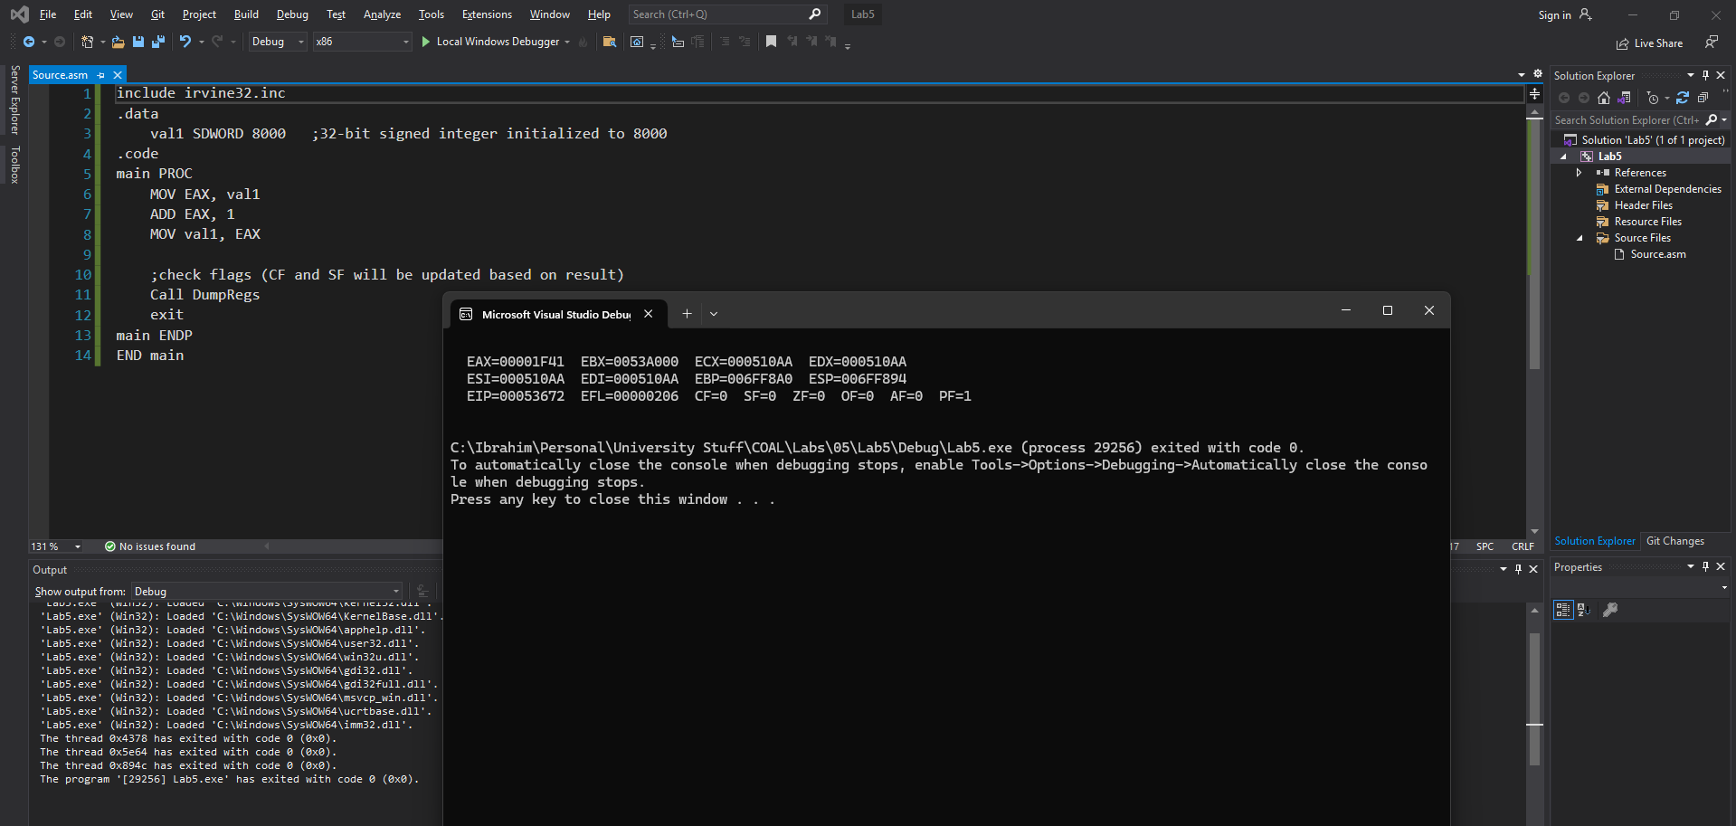

* Carry Flag (CF) = 0 (no unsigned overflow)
* Sign Flag (SF) = 0 (result is positive)

***Task 2:***

MOV AX, 7FF0h

ADD AL, 10h

1. CF = 1, SF = 0, ZF = 1, OF = 0

ADD AH, 1

1. CF = 0, SF = 1, ZF = 0, OF = 1

ADD AX, 2

1. CF = 0, SF = 1, ZF = 0, OF = 0

***Task 3:***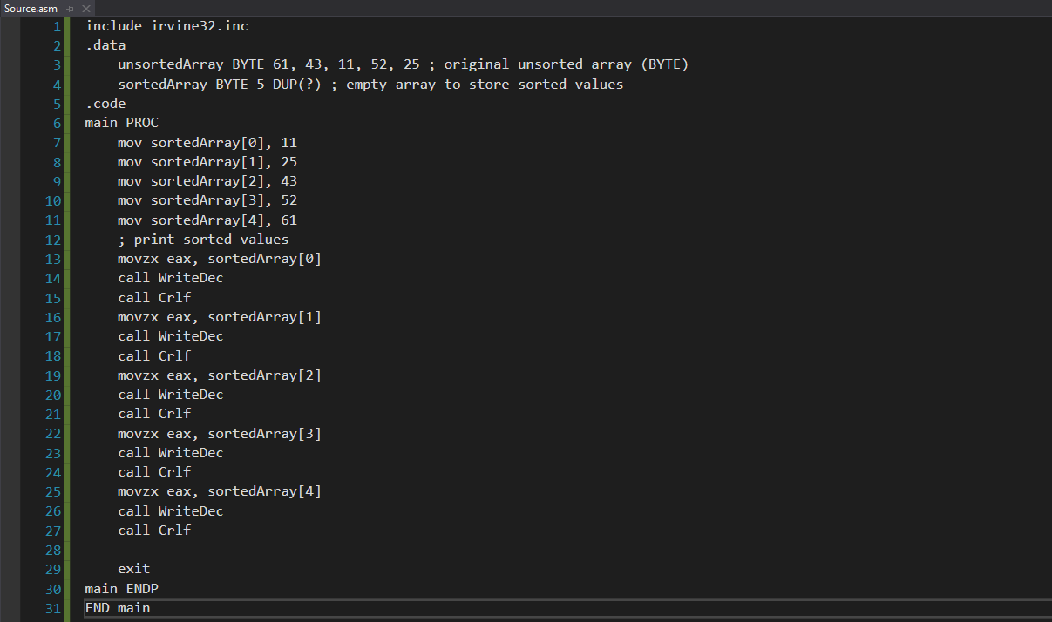

***Task 4:***

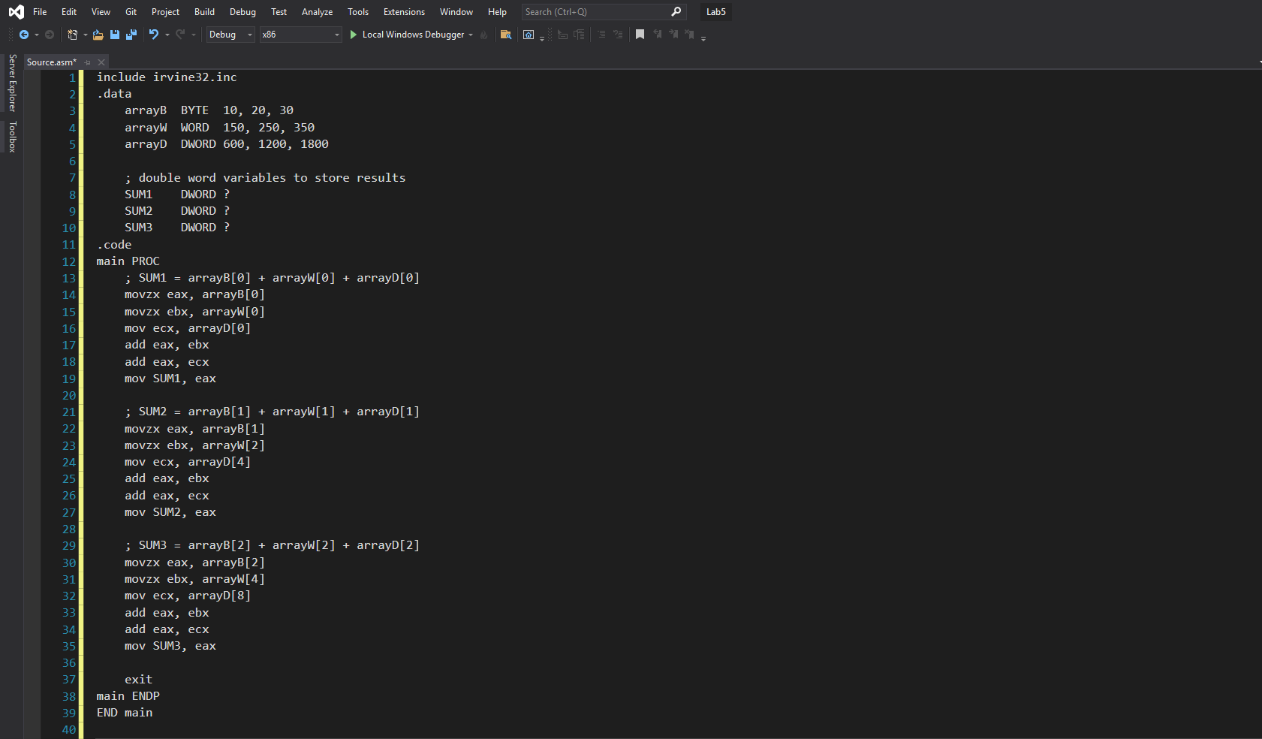

***Task 5:***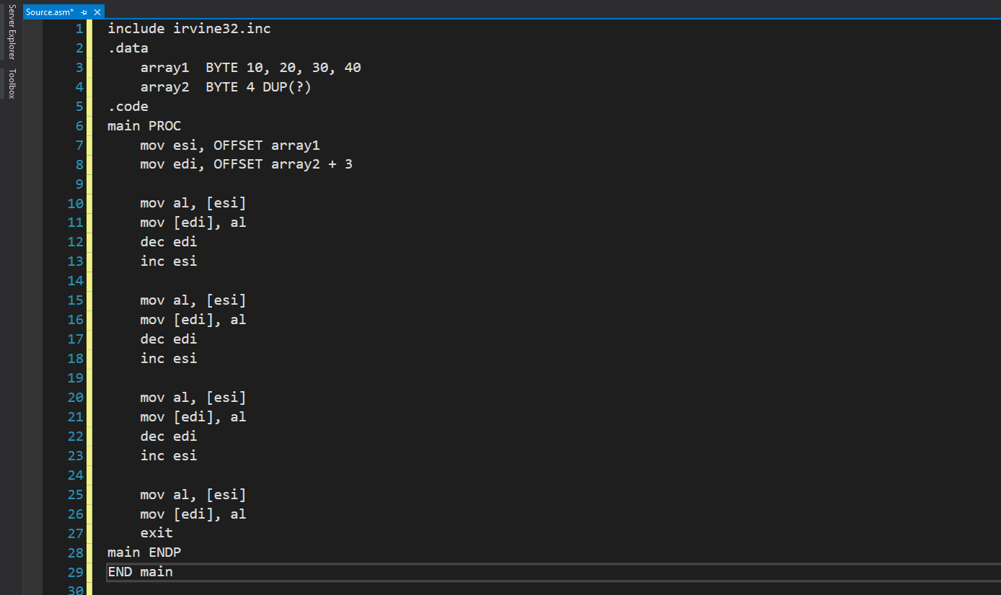

***Task 6:***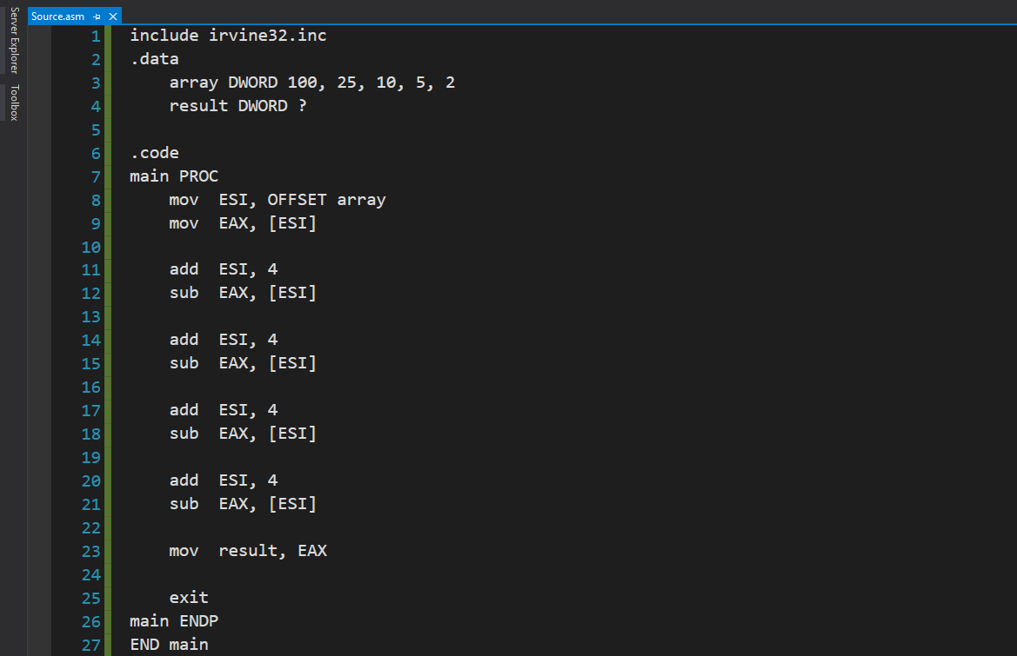

***Task 7:***